**Nagendra Nepal**

**Introduction of socket programming**

Sockets provide the communication mechanism between two computers using TCP. A client program creates a socket on its end of the communication and attempts to connect that socket to a server. When the connection is made, the server creates a socket object on its end of the communication.

A socket is an endpoint of a two-way communication link between two programs running on the network. Socket is bound to a port number so that the TCP layer can identify the application that data is destined. to be sent. Socket programing is the key API for programming distributed applications on the Internet

**Basic principles of Socket Programming**

**Program.**A program is an executable file residing on a disk in a directory. A program is read into memory and is executed by the kernel as a result of an exec() function. The exec() has six variants, but we only consider the simplest one (exec()) in this course.

**Process.**An executing instance of a program is called a *process*. Sometimes, *task*is used instead of process with the same meaning. UNIX guarantees that every process has a unique identifier called the *process ID*. The process ID is always a non-negative integer.

**File descriptors.**File descriptors are normally small non-negative integers that the kernel uses to identify the files being accessed by a particular process. Whenever it opens an existing file or creates a new file, the kernel returns a file descriptor that is used to read or write the file. As we will see in this course, sockets are based on a very similar mechanism (socket descriptors).

**The client-server model**

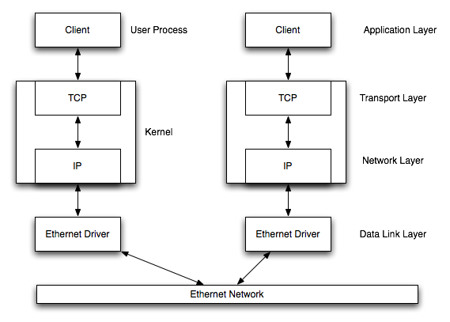

### Transmission Control Protocol (TCP)

TCP provides a *connection oriented service*, since it is based on connections between clients and servers.

TCP provides reliability. When a TCP client send data to the server, it requires an acknowledgement in return. If an acknowledgement is not received, TCP automatically retransmit the data and waits for a longer period of time.

TCP is instead a byte-stream protocol, without any boundaries at all.

TCP is described in RFC 793, RFC 1323, RFC 2581 and RFC 3390

java.net.Socket and java.net.ServerSocket are the java classes that implements Socket and Socket server.

**PalindromeChecker**

**FlowChart:**

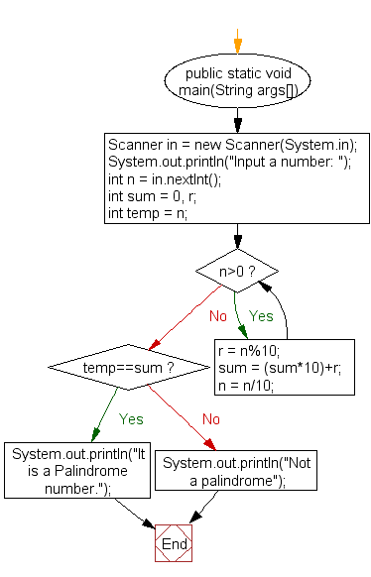

**Algorithm :**

public boolean isPalindrome(String text) {

    String clean = text.replaceAll("\\s+", "").toLowerCase();

    int length = clean.length();

    int forward = 0;

    int backward = length - 1;

    while (backward > forward) {

        char forwardChar = clean.charAt(forward++);

        char backwardChar = clean.charAt(backward--);

        if (forwardChar != backwardChar)

            return false;

    }

    return true;

}

I wrote about socket programming and uses of it and use it to test the code. I also created flowchat and algorithm for it.